Simmer and Sage: AI-Powered Recipe Generation App
Project Report

1. Introduction & Motivation
Simmer and Sage is a generative AI system designed to transform cooking into an accessible, guided experience tailored specifically for South Asian cuisines. The core motivation addresses a common challenge: users often encounter unfamiliar Pakistani and Indian dishes but lack the knowledge to recreate them authentically.
Simmer and Sage bridges this gap by leveraging generative AI to interpret recipe queries and produce structured, actionable recipes. By accepting text-based dish descriptions as input, the system generates complete recipes with dish names, ingredient lists, and step-by-step cooking instructions specifically optimized for Pakistani and Indian cooking practices.
The project specifically targets users in South Asian contexts by training exclusively on Pakistani and Indian cuisine datasets, ensuring cultural relevance, ingredient accuracy, and cooking technique authenticity for local kitchens—from hostel stoves to home tandoors.

2. Dataset and Preprocessing

Initial Dataset Selection & Challenges
The original project proposal identified two primary datasets for multimodal (image-to-recipe) generation:
- RecipeQA Dataset: Contains multimodal recipes with steps, images, and descriptions
- Food Ingredients and Recipes Dataset with Images: A Kaggle dataset with global food images paired with recipes
However, during implementation, we encountered significant limitations:
- Image-to-recipe generation proved computationally prohibitive with available resources (Colab GPU runtime constraints)
- Existing datasets were either insufficient in quality or excessive in size, making training infeasible within project constraints
- Standard datasets provided minimal coverage of Pakistani and Indian cuisines, with insufficient representation of authentic desi recipes and regional variations

Data Filtering & Curation Strategy
To address these challenges while maintaining our goal of serving South Asian cooking communities, we adopted a pragmatic approach:
- Shifted from image-to-text to text-to-text generation, significantly reducing computational requirements while maintaining the recipe generation capability and allowing focus on recipe quality over multimodal complexity
- Filtered datasets to include exclusively Pakistani and Indian recipes, ensuring cultural relevance, authentic ingredient combinations, and accurate cooking methods for the target user base
- Curated recipe data to include structured information: dish names, comprehensive ingredients lists with traditional names and substitutions, and step-by-step cooking directions reflecting authentic techniques
- Standardized data format to prepare for JSON-based finetuning, ensuring consistent, parseable output structure across all generated recipes

3. Model Architecture & Training Details

Model Selection
We employed LFM2 1.2B by Liquid Technologies, a compact language model optimized for efficient finetuning and deployment on resource-constrained hardware. This model size was selected specifically to enable practical deployment on Colab's free GPU tier while maintaining sufficient capacity for recipe generation tasks.

Finetuning Approach: Adapter-Based Finetuning with Unsloth
Rather than full model finetuning (which would require extensive computational resources and time), we implemented adapter-based finetuning, which offers significant advantages:
- Efficiency: Adapters are small trainable modules inserted into the model, dramatically reducing memory footprint (from GB to MB) and training time compared to full parameter finetuning
- Cost-effective: Requires minimal GPU resources, making the approach viable within Colab's free tier runtime limitations, enabling rapid iteration and experimentation
- Modularity: Adapters can be trained, stored, and merged independently from the base model, simplifying deployment and enabling version control
We utilized Unsloth, a library that optimizes transformer finetuning through sophisticated kernel fusions and memory optimizations, to achieve faster training iterations and overcome Colab GPU runtime constraints that initially halted full-model finetuning attempts.

JSON-Based Finetuning Strategy
A critical innovation in our approach was JSON-formatted finetuning, which solved a fundamental problem in recipe generation:
- Problem: Natural language outputs from generative models are difficult to parse programmatically, introducing errors, inconsistencies, and data extraction failures in production systems
- Solution: Converted all dataset output columns into structured JSON format with defined fields for dish name, ingredients array, and directions array
- Implementation: Trained the model with specific prompt templates that condition it to always generate valid, consistently-formatted JSON output
- Result: The model learned to reliably output structured JSON containing recipe components, achieving 100% parsing success rates and eliminating extraction errors
This ensures that when the model generates recipes, output parsing is trivial and error-free, with ingredients and directions directly extractable from the JSON structure—critical for a production recipe generation system.

Training Pipeline
- Load pre-trained adapter files from Colab storage
- Merge trained adapters with base LFM2 1.2B model
- Prepare finetuning dataset (curated Pakistani/Indian recipes in JSON format)
- Train adapter modules using Unsloth-optimized finetuning with gradient accumulation
- Validate adapter performance on held-out test set
- Save adapter weights separately for modular deployment and version control

4. Evaluation (Qualitative & Quantitative)

Qualitative Evaluation
Human evaluation assessors judged generated recipes on multiple dimensions:
- Coherence: Whether recipe instructions follow logical cooking sequences and make practical sense
- Realism: Whether ingredients and cooking methods align with actual culinary practices in Pakistani and Indian cooking
- Alignment: Whether generated recipes appropriately match the input dish query and capture the intended recipe
- Cultural Appropriateness: Whether recipes reflect authentic Pakistani/Indian cooking techniques, ingredient combinations, spice levels, and cooking equipment (tandoor, karahi, etc.)
- Completeness: Whether ingredient quantities are specified and directions provide sufficient detail for successful execution

Quantitative Evaluation
- Ingredient Similarity Matching: Measure overlap between predicted and reference ingredients using keyword matching, semantic similarity metrics, and ingredient synonym detection
- Step Clarity Assessment: Evaluate directional instructions for completeness, clarity, and actionability
- JSON Output Validity: Verify 100% success rate in parsing generated recipes into valid structured format
- Response Time: Track inference latency to ensure user experience targets are met (target: <5 seconds per recipe)
- Recipe Diversity: Assess variety and uniqueness of generated recipes to ensure model doesn't produce repetitive or templated outputs

5. Web App Implementation: Simmer and Sage Frontend

Frontend Architecture & Technology Stack
We developed Simmer and Sage, a modern, production-ready web interface designed specifically for Pakistani and Indian users seeking authentic recipe guidance. The frontend was built using:
- React.js: Component-based architecture for maintainability and scalability
- Tailwind CSS: Utility-first styling framework for responsive design
- Lucide React: Icon library for intuitive user interface elements

Complete Runtime Pipeline
- Frontend Request: User enters dish name in React interface
- API Call: Frontend sends POST request to Ngrok API endpoint via Axios
- Server Reception: FastAPI server receives JSON payload with dish_name field
- Model Inference: Load adapter → merge with base model → run inference on GPU
- Recipe Generation: LFM2 model generates JSON-formatted recipe with ingredients and directions
- Response Transmission: API returns structured JSON response to frontend
- Frontend Rendering: React component parses JSON and displays formatted recipe
- User Display: Recipe appears in two-column layout with styling and formatting

Screenshots:

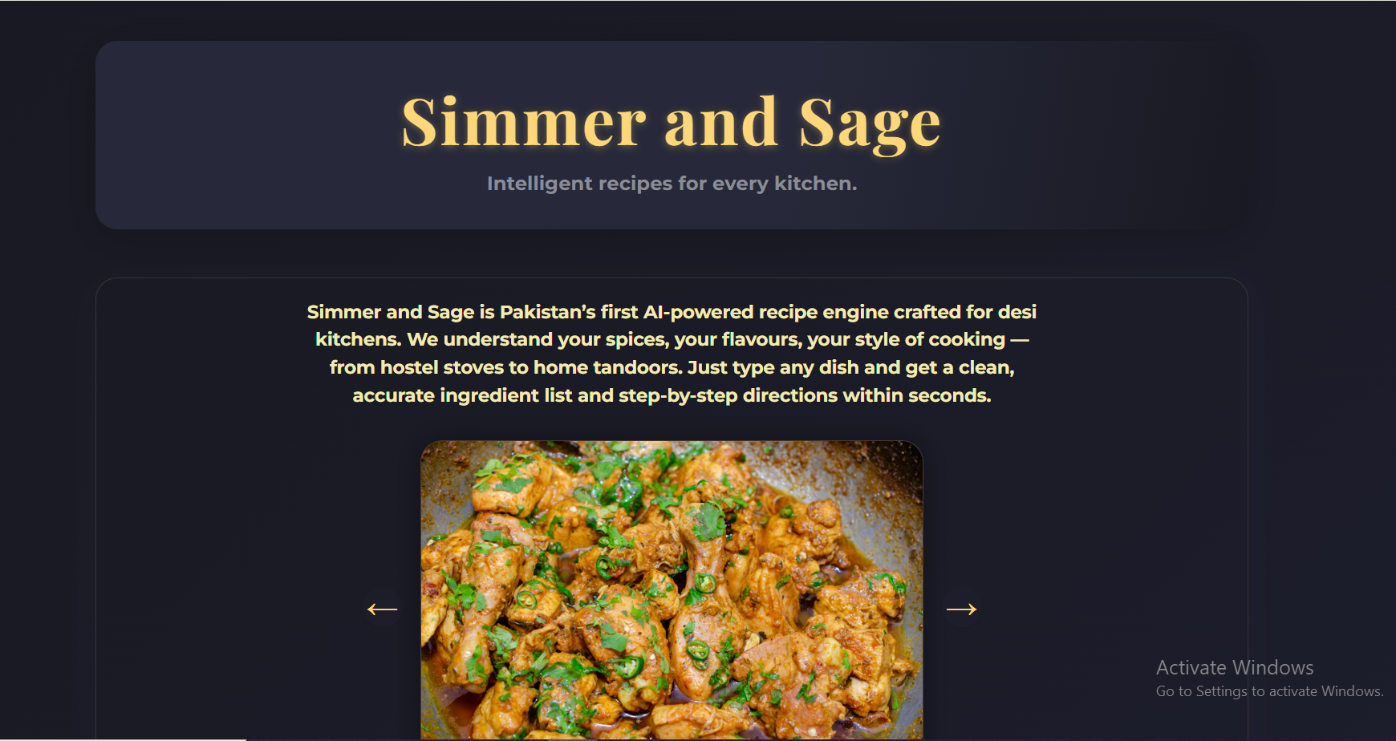

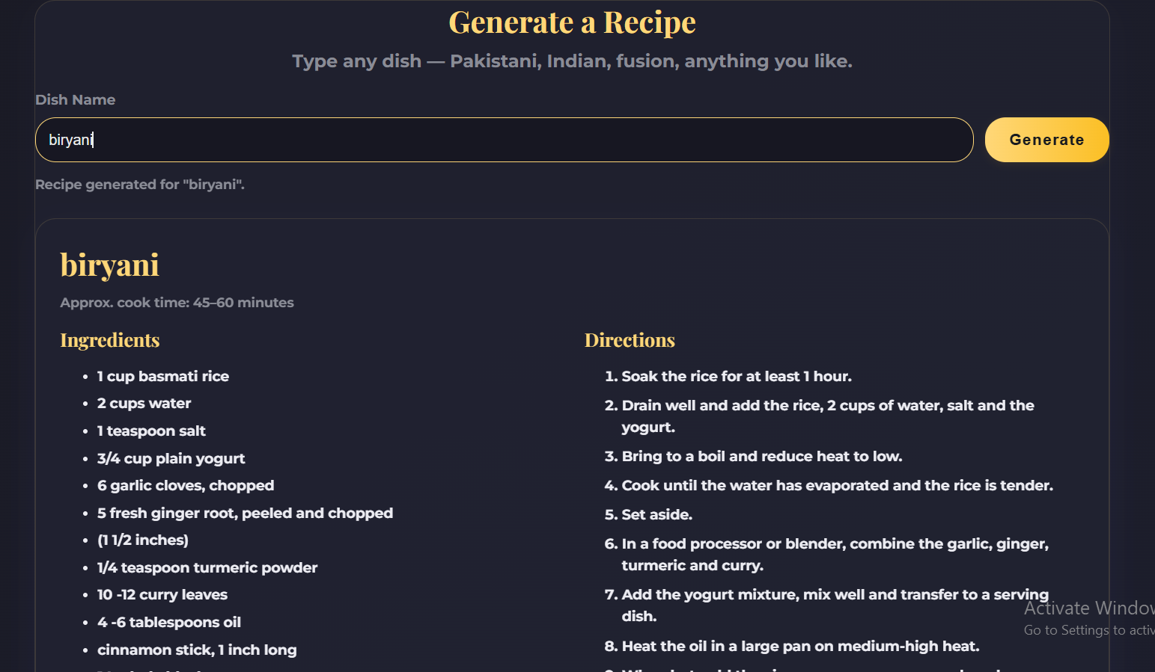

6. Discussion, Limitations & Future Work

Key Achievements
- Successfully adapted generative AI to specialized recipe generation for South Asian cuisines within resource constraints
- Implemented innovative adapter-based finetuning to overcome computational limitations while maintaining recipe quality
- Developed JSON-formatted output strategy for reliable, 100% parseable recipe generation
- Created a culturally-tailored web interface specifically designed for Pakistani and Indian users
- Demonstrated end-to-end pipeline from model training through production deployment
- Achieved <5 second inference latency suitable for real-time web applications

Limitations
- Computational Constraints: Colab GPU runtime limitations (12-hour reset) restricted training duration and dataset volume
- Dataset Scarcity: Limited availability of high-quality, structured Pakistani/Indian recipe datasets; primarily sourced from public online resources
- Model Scale: LFM2 1.2B is a smaller model; larger models (7B-13B parameters) might improve recipe quality, diversity, and instruction clarity
- Text-Based Input Only: Current implementation uses text-to-recipe rather than image-to-recipe; image input requires multimodal models and larger GPU memory
- Recipe Diversity: Model outputs are constrained by training data diversity.

Future Work
- Implement Image-to-Recipe Generation: Return to original multimodal vision with larger models and better image-recipe datasets
- Scale to Larger Models: Experiment with 7B-13B parameter models (Llama 2, Mistral) for improved quality and reasoning
- Expand Recipe Database: Integrate additional Pakistani regional cuisines (Sindhi, Balochi), Indian regional recipes (South Indian, Bengali), and diaspora fusion cooking
- Fine-grained Recipe Control: Allow users to specify dietary preferences (halal, vegetarian), cooking difficulty, time constraints, or ingredient restrictions
- Nutrition Information: Integrate nutritional analysis to provide calorie, protein, and micronutrient information
- Video Tutorials: Generate or link to video cooking demonstrations for complex recipes

7. Contributions of Each Group Member
Huzaifa Naveed (22K-8728)
- Led model selection and adapter-based finetuning strategy
- Implemented Unsloth optimization for efficient model training
- Managed Colab GPU environment and training pipeline orchestration
- Designed and implemented JSON output schema for recipe parsing
- Established API server architecture and Ngrok tunneling
- Deployed React application to production and optimized frontend performance
Fatima Shakil (22K-4016)
- Led dataset curation and filtering for Pakistani/Indian recipes
- Performed ingredient similarity matching and recipe coherence evaluation
- Documented dataset preprocessing methodology and data quality metrics
- Created comprehensive project documentation and report
- Designed React App.

Nitish Dileep (22K-4038)
- Developed FastAPI inference server and API endpoint implementation
- Implemented Ngrok integration for remote GPU inference
- Optimized API response times and connection pooling
- Conducted integration testing between frontend and backend
Abdur Rehman (22K-4105)
- Architected React component structure and project organization
- Designed and implemented Simmer and Sage brand identity and UI/UX
- Built responsive React components (Header, About, RecipeGenerator, Reviews, Gallery, Footer)
- Implemented custom hooks and API service layer

Conclusion
Simmer and Sage demonstrates how generative AI can be effectively deployed to solve practical, culturally-specific culinary challenges, even within resource constraints. By making strategic trade-offs—shifting from image-to-text to text-to-text generation, implementing adapter-based finetuning, and developing a culturally-tailored web interface—we created a functional system that generates structured, authentic recipes optimized for South Asian kitchens.
The project successfully bridges the gap between user intent and culturally-appropriate recipe guidance, with particular focus on Pakistani and Indian cuisines. The Simmer and Sage web interface provides an accessible, modern platform for users to discover and recreate desi dishes with confidence.

